Rock the Lough 2025 - event information Sun 14th Sept

St Peter’s AC is pleased to be back this year with their Rock the Lakes and Lough event..
Numbers have been posted out: tee shirt and medal pick up at end of race at finish line at South Lake Leisure Centre.

WHERE? All races starting at South Lakes Leisure Centre, Craigavon, Northern Ireland
WHEN? Sunday 14th Sept 2025

RACES START TIMES. 1K FUN RUN 9:20am
RACES START TIMES. HALF MARATHON 9:40am
RACES START TIMES. 10K RUN 9:45am
RACES START TIMES. 5K RUN 9:50am

Prizes
1ST 2ND and 3RD for both male and female in the 3 races will be presented at the finish line. My Run Results decision is final.
The route for all events is flat and fast, the setting is idyllic, encompassing both Lakes, with the half marathon taking in the beautiful Oxford Island trails.
The whole St Peters club would like to thank you for supporting our event and would encourage your family and friends to come along to show their support.
The chipped timing of the race is being handled by My Run Results.

Race Information
All races will begin and end at the South Lake Leisure Centre in Craigavon. Allow space at the front of the Start Area for the fastest runners. There will be pacers in the half marathon and 10k help runners achieve their target time.
The 5k and 10k races will circle the Lakes, whilst the half-marathon will also incorporate the Link roads to Oxford Island. There embarking on a loop of Oxford Island’s trails and returning by the Link Roads to Craigavon Lakes, where they will finish back at the Leisure Centre, and enjoy a well-deserved rest and refreshment.

Running on Public Roads
The 5k and 10k is wholly within the boundaries of Craigavon Lakes and therefore off-road. Although it will be open to members of the public, walking, cycling, prams and dogs. The paths are wide and can accommodate everyone if tolerance is shown. Please respect other users. The half-marathon includes not only Craigavon Lakes, but also the cycle-paths and public road to Oxford Island, where it then navigates the trails around the Island, The section of the public road that the route will take will be under traffic management for our event.

Use of Headphones on Road Races
Under UK Athletics Rule 240 S5 the wearing of headphones is not permitted in races on single carriageway roads not wholly closed to traffic. Athletics Northern Ireland will be enforcing this rule. It is the Race Organiser’s responsibility to ensure this rule is enforced as any incidents or accidents relating to a breach of the rule may invalidate the race insurance.

Half marathon
Will have a lead bike in front and a tail bike at rear.

Emergency and First Aid To assist us we will have an Event medical team from St Johns Ambulance in attendance. If you see someone in trouble please come to their assistance and ask someone to contact the nearest marshal.

Water Stations
There are Water stations for runners at the 3m, 6m, 9m markers and at the finish. Water will be served in cups.

Changing Facilities
There will be no changing or showering facilities available at the Leisure Centre. All runners should arrive, changed and ready to go! Food and refreshments will be provided at the finish area after the event by St Peter’s AC.

Toilets
We have booked portable toilets at race start and they will be there until race end. Enroute you will pass public toilets at Mullen Marina in Oxford Island at around 5.5 miles and the Discovery Centre Oxford Island around the 7.5 mile mark and many trees along the way!

Car Parking
Please note that there will be no parking spaces available at the South Lake Leisure Centre for runners at our event. Instead the car parks for our event will be located close by at the Craigavon Civic Centre (235 spaces available) and Rushmere Shopping Centre (up to 1800 spaces), On the day of the event we will have event marshals in place to direct runners from the Car Parks to the Starting Area at the Leisure Centre. To
avoid traffic congestion, please arrive in good time.

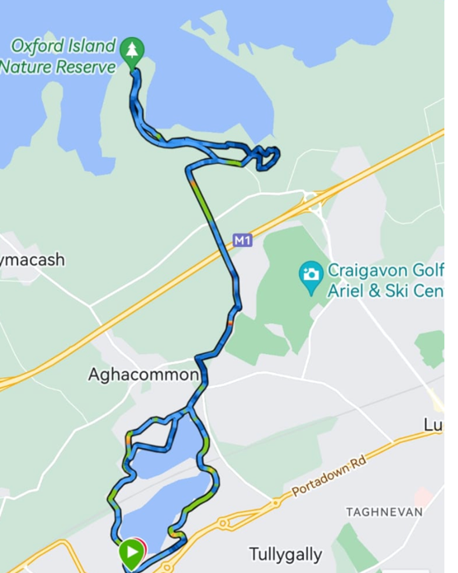
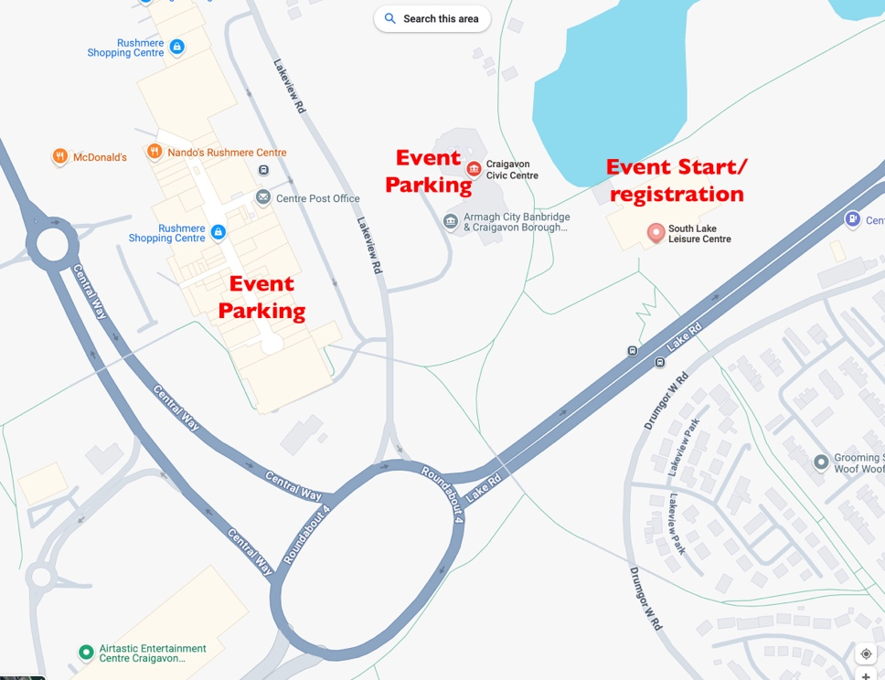
Half marathon=1 full lap of lakes, followed by 1 half lap of lakes, head to Oxford Island, lap of Island back and complete lakeside route around 2nd lake.
10k =2 laps of lakes 5k= 1lap of lakes. 1k =fun run up the first hill of the lakes

